
Anekant Education Society's

Tuljaram Chaturchand College of Arts, Science and Commerce
Baramati (Autonomous)

Department of BBA(CA)
A Project report on

“Coffee Shop Management System”

Submitted in partial fulfillment of the requirements
For the award of degree of BBA(CA)
Submitted by
1)Mr. Tejas Shinde
Seat No: - 3964
2)Mr. Tejas Taware
Seat No: - 3962

Under the guidance of
Ms. M.R. Saste


Anekant Education Society’s
Tuljaram Chaturchand College of Arts, Science and Commerce
Baramati (Autonomous)
Department of Computer Application

CERTIFICATE
Seat No: - 3964 Date: - 08/04/2024
Seat No: - 3962

This is to certify that the project entitled “Coffee Shop Management System” submitted by Mr. Tejas Rupesh Shinde and Mr. Tejas Santosh Taware in partial fulfillment of the requirements for the award of degree of BBA(CA) to Savitribai Phule University of Pune, has been carried out by them under my guidance satisfactorily during the academic year 2023-2024.

Project Guide H.O.D

Internal Examiner External Examiner

ACKNOWLEDGEMENT

We are thankful to Prof Dr A.S. Jagtap Principal of Tuljaram Chaturchand College, Baramati for making available all the required resources and co-operation in our project work.
We are thankful to Prof. Saste M.R Head of BBA(CA) Department. Tuljaram Chaturchand College, Baramati for making available all the required resources and co-operation in our project work.
It gives us great pleasure to express gratitude to Prof. Mrs. M.R. Saste for her valuable guidance and suggestion while preparing this project.
I wish to express my sincere thanks to BBA(CA) Department and all teaching and non-teaching staff. For their extraordinary help throughout the period of my project. We are especially thankful to those who helped us directly-indirectly in completion of this work successfully.

Date: 08/04/2024 Name: Shinde Tejas Rupesh [3964]

Place: Baramati Taware Tejas Santosh [3962]

INDEX
Sr.  No | Contents | Page.  No
1 | Project Title | 1
1.2 | Introduction | 5
1.3 | Scope of the System | 6
1.4 | Existing System | 7
1.5 | Proposed System | 7
1.6 | Software and Hardware Requirements | 8
1.7 | Modules | 8
2 | Feasibility Study | 9
3 | System Design | 10
3.1 | E-R-Diagram | 10
3.2 | Context Level Diagram | 11
3.2.1 | DFD (Level 0) | 11
3.2.2 | DFD (Level 1) | 11
3.3 | Activity Diagram | 12
3.4 | Sequence Diagram | 13
3.5 | Class Diagram | 14
3.6 | Component Diagram | 15
3.7 | Deployment Diagram | 15
3.8 | Use Case Diagram | 16
3.9 | State Diagram | 17
4 | Collaboration Diagram | 17
5 | Data Dictionary | 18
6 | Design of Inputs | 19
7 | Reports | 21
8 | Future Enhancement | 22
9 | Bibliography | 23
10 | Sample Code | 24

1.2 INTRODUCTION

The restaurant industry is known for particularly low profit margins. This project focuses on small businesses, café, especially those that serve fast food.

The backbone of experimentation for applying though these accounting processes is local café restaurant in which the managers are in warehouse of how food cost and operating expenses could be combined to provide meaningful cost information.

The café management system. Is existing mishaps cafeteria to manager cafeteria daily processes such as order & bill.

This process also gives the interface for bill painting purpose in instant time.

1.3 Scope of System

The scope of the Coffee Shop Management System includes the following key aspects:

- It is designed to increase operational efficiency, saving our money and time maximizing profit and provide more security. It is designed to avoid paperwork.

- Cafeteria Management especially manage the menu items, gives interface to the orderings, expenditure reports, user to manage the items and inventory.

- It aims to maximize the productivity and provide improved manage system. The system will be easy to understand and use more specifically. The system is designed to allow an admin to manage the products records and other management in coffee shop.

- Whereas it maintains the relationship between customers and the admin in a technical way, with the help of coffee shop management software, the software will facilitate creation of different reports.

1.4 Existing System

- In existing system. There is no ordering system, and there is. No billing software. Therefore, it is very hard to connect with new generation also in existing there is a lot of manual work. So, it is very time-consuming process.

- The existing system for Coffee Shop Management typically involves manual and paper-based processes, which can be time-consuming, error-prone, and inefficient.

- Manual Data Entry: Product information is often stored in physical files or spreadsheets, requiring manual data entry and updating.

1.5 Proposed System

- To overcome all the problems faced in the existing system, we apply billing as well as other facilities that are not present in the existing system.

- It will keeps everything as simple as possible. Also, we are making marketing as well, selling using this software.

- Inventory and Stock Management:
Ingredient Tracking: Monitor and manage the stock of coffee ingredients and other consumables.
- Simple menu set up, user friendly order management.

1.6 Software and Hardware Requirements

Software Requirements -
- Operating System: WINDOWS OS (Windows 7, 8,10,11)
- Frontend: VB.NET
- Backend: SQL Server For Database Connectivity
- Integrated Development Environment (IDE): Visual Studio 2019

Hardware Requirements -
- Processor: Intel I3 2.8 GHz Processor and Above
- RAM 4 GB and Above
- Operative Memory required for the software MB
- 500 MB of free disk space for Eclipse installation
- Additional disk space for your projects and any additional plugins or extensions

1.7 Modules

Functional Admin panel:
- Allows admins to manage the whole system.
- CRUD functionalities: Allows admin to create, read, update and delete their product details in a managed format.
- Report Generation : Allows admin to generate report to track the inventory
- Secure login option for admin.
- Allows employee to manage billing dashboard easily & generate the bill in pdf format

2. Feasibility Study

In order to do a feasibility study, we must consider the following:
- Technical Feasibility The availability of hardware & Software necessary for the creation of the system, as-well-as the compatibility and maturity of the technology planned to be used, and the availability of the requisite technical staff to create the system, are all factors to consider.
- Operational Feasibility Problems that may develop during operations are the focus of operation feasibility. There are two parts to this problem to consider:
• What are the chances that the solution provided will not be used or will
not work?
• What is the inclination of-the management and end users towards
the solution?
- Economic Feasibility The concept of economic feasibility is determining whether or not the potential benefit of fixing difficulties is worthwhile. Because member needs &alternative solutions haven’t been specified at this point, it is difficult to estimate the cost at this level.

3.System Design

3.1 E-R-Diagram

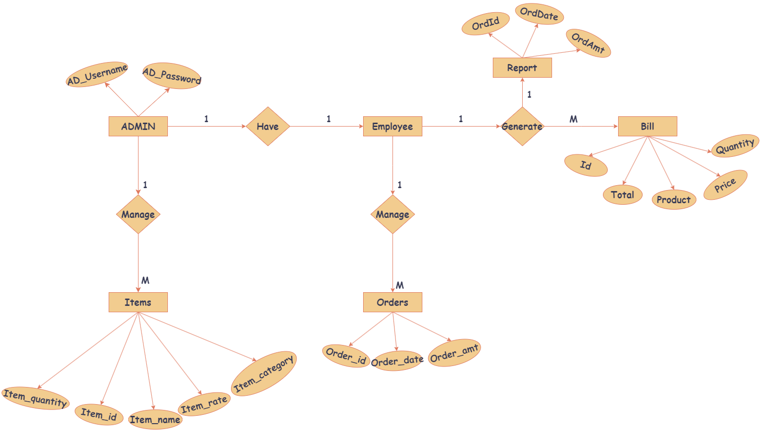

3.2 Context Level Diagram

3.2.1 DFD (Level 0)

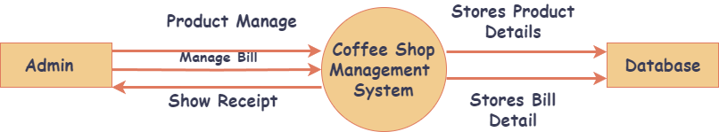

3.2.2 DFD (Level 1)

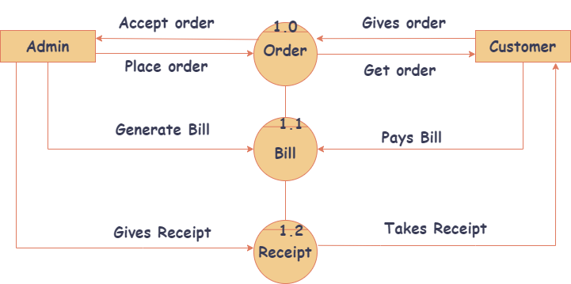
3.3 Activity Diagram

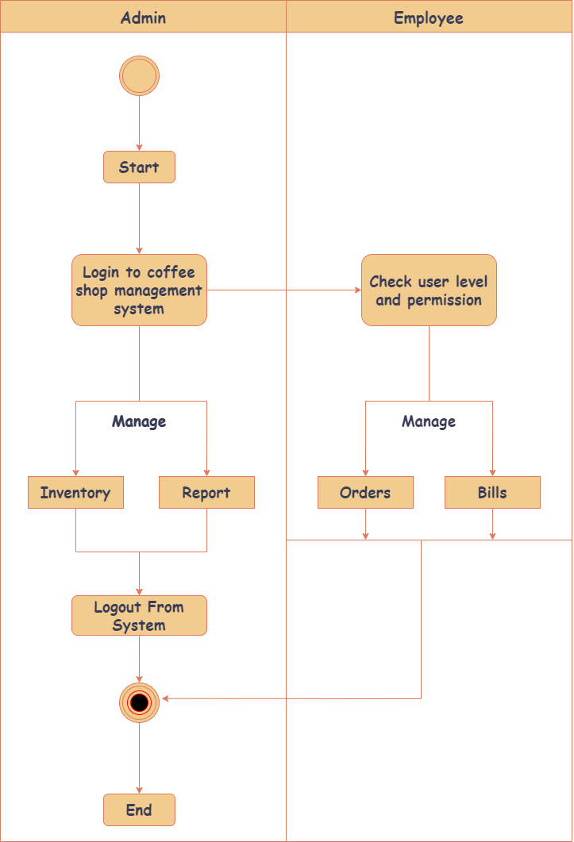

3.4 Sequence Diagram

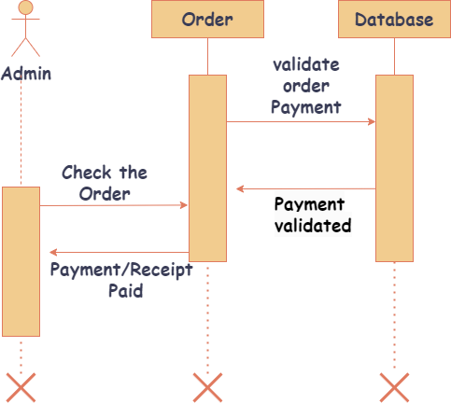

3.5 Class Diagram

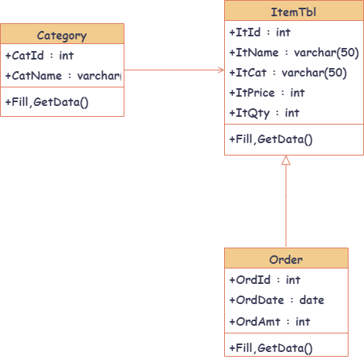

3.6 Component Diagram

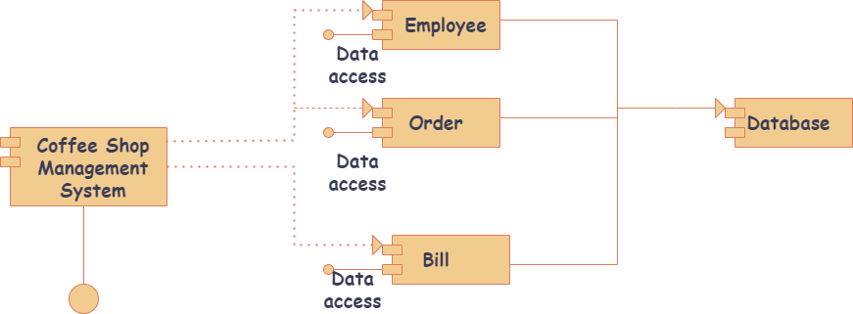

3.7 Deployment Diagram

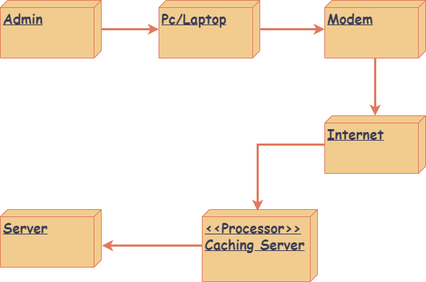
3.8 Use Case Diagram

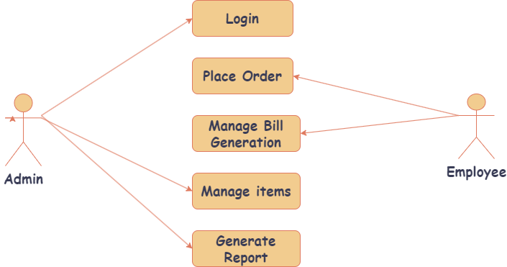

3.9 State Diagram
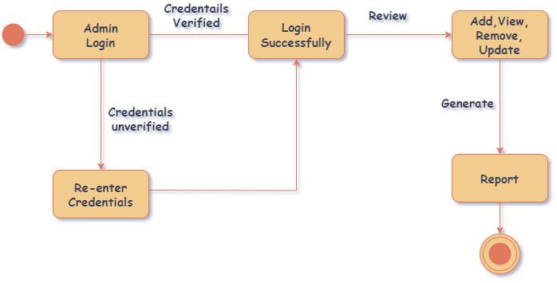

4.0 Collaboration Diagram

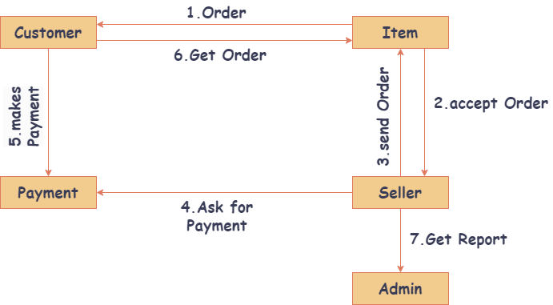

5.Data Dictionary

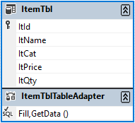

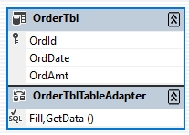

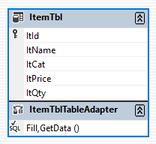

6. Design of Inputs

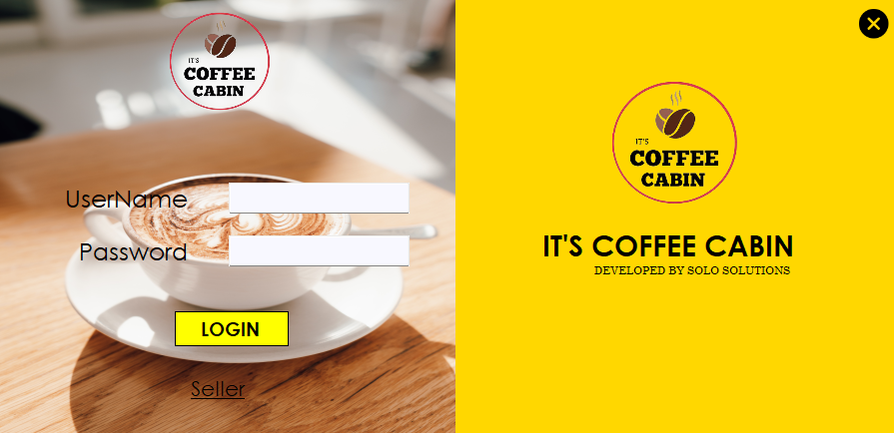

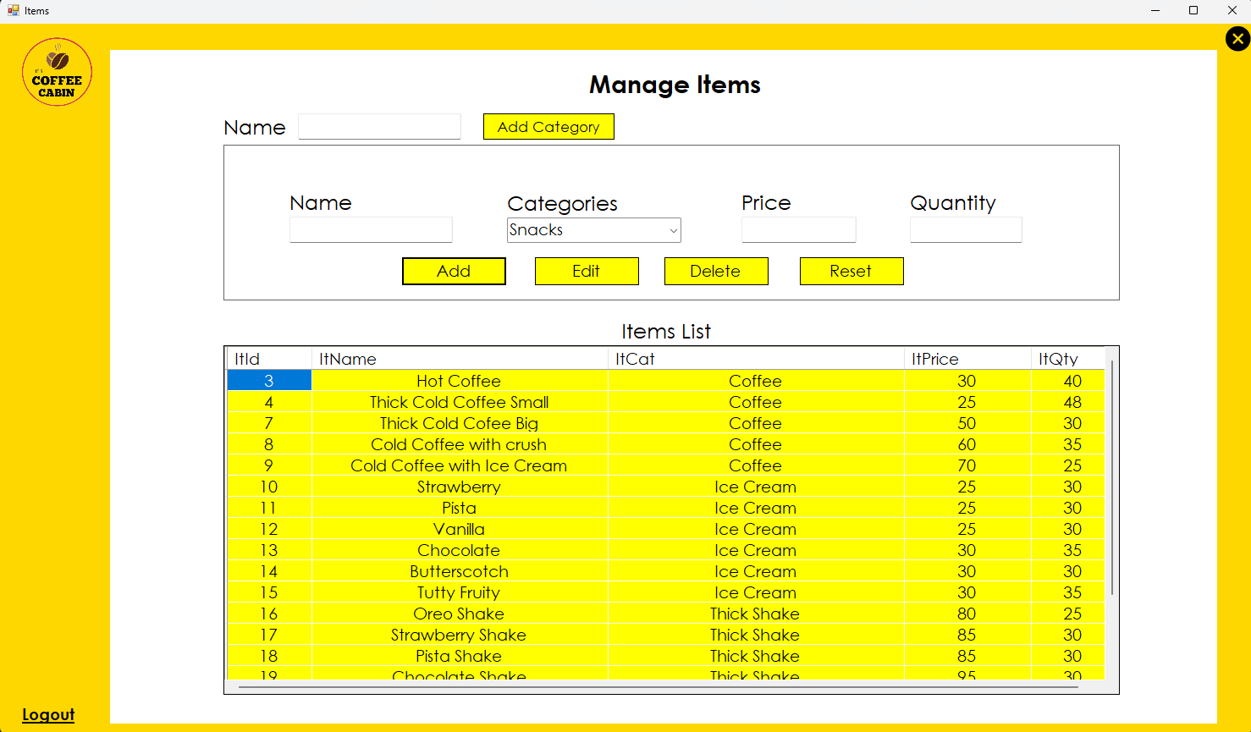

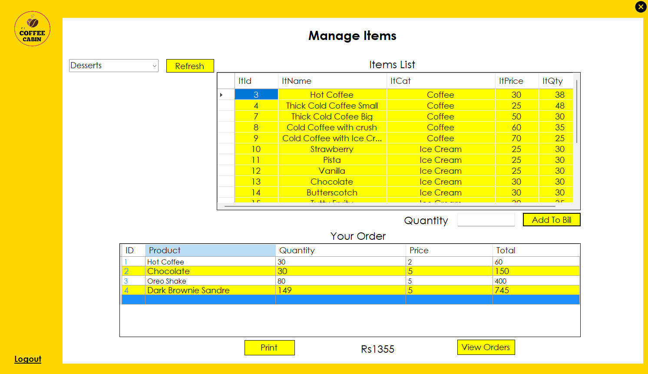

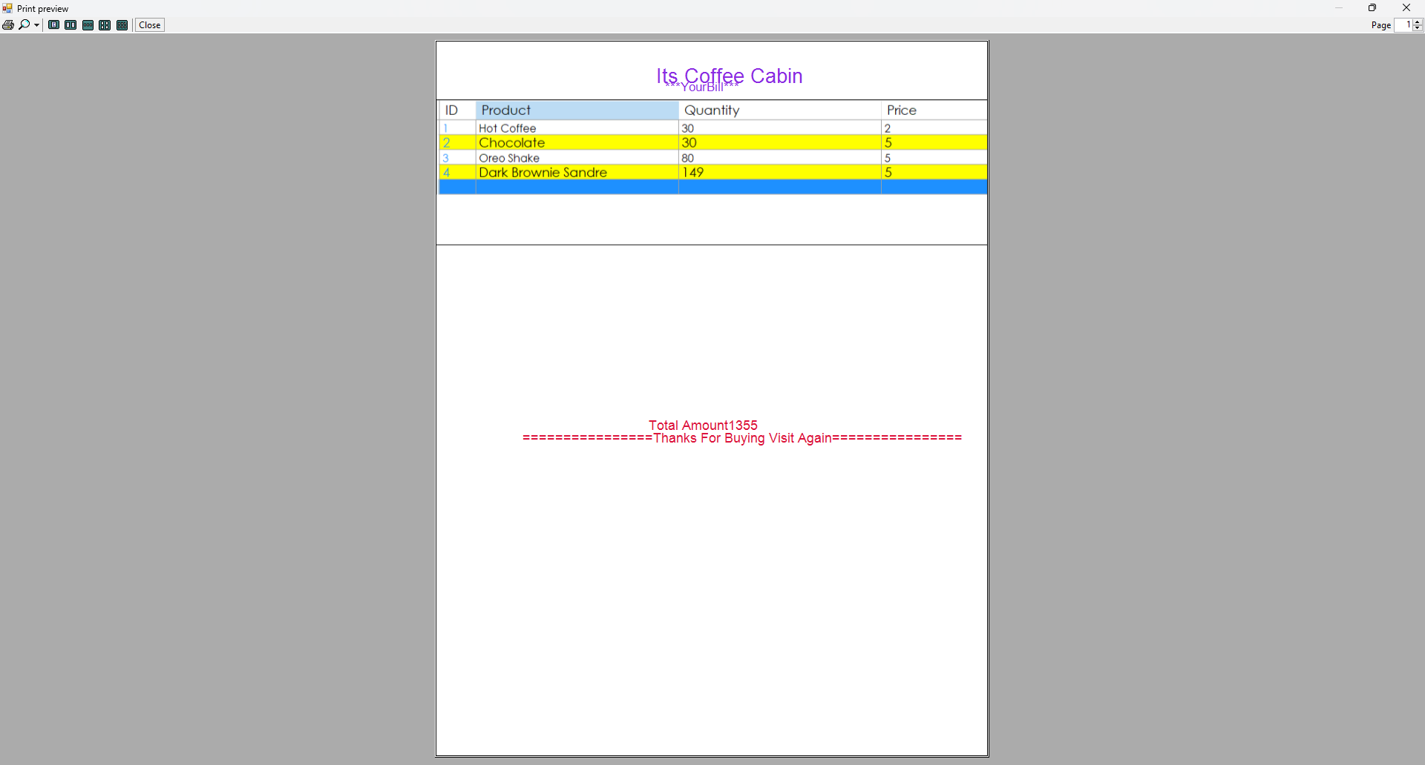
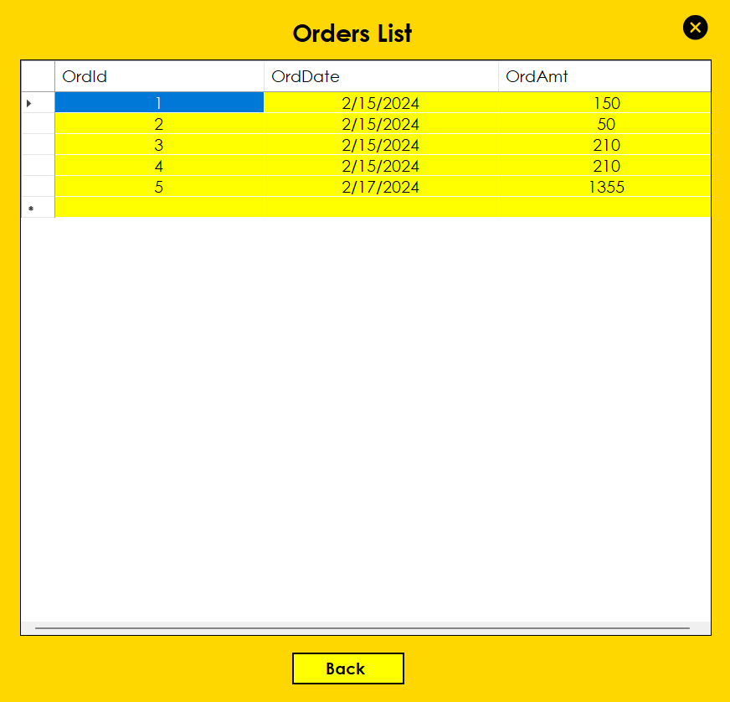

7. Reports
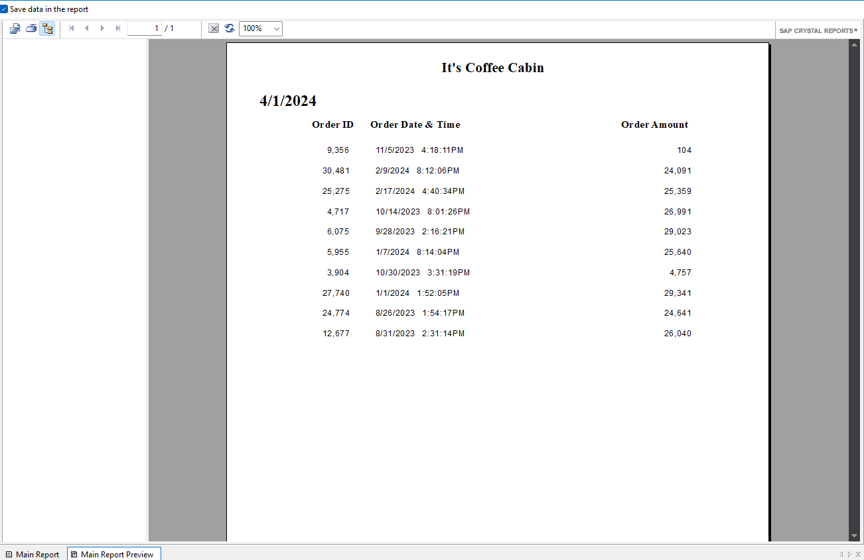
8. Future Enhancement

The GUI and the features added to this system are the basic ones. In future, there will be a better Graphical User Interface and there will be more features added to this system.
- Inventory Management:
Enhance inventory tracking capabilities with features like barcode scanning, automatic reorder alerts, and batch management.
Implement inventory forecasting algorithms to predict stock levels and optimize inventory replenishment.
Integrate with suppliers and vendors for real-time inventory updates and streamlined procurement processes.

- Payment Gateway Integration:
Integrate with popular payment gateways (e.g., PayPal, Stripe, Square) to facilitate online payments and secure transactions.
Support multiple payment methods including credit/debit cards, digital wallets, and bank transfers.
Ensure compliance with payment card industry (PCI) standards and data security regulations.

- Security Enhancements:
Strengthen data security measures with encryption, access controls, and audit trails to protect sensitive information.
Implement user authentication mechanisms such as multi-factor authentication (MFA) and role-based access control (RBAC) to prevent unauthorized access.
Regularly update the software with security patches and bug fixes to address potential vulnerabilities.

9.Bibliography

- Albahari, Joseph, and Ben Albahari. "C# 9.0 in a Nutshell: The Definitive Reference." O'Reilly Media, 2021.
- Liberty, Jesse, and Brian MacDonald. "Programming Visual Basic .NET." O'Reilly Media, 2002.
- Michel, Michael, and Eric Lippert. "Visual Basic .NET Language in a Nutshell." O'Reilly Media, 2002.
- Sheldon, Sue. "Visual Basic .NET Programming for the Absolute Beginner." Cengage Learning, 2002.
- Microsoft Docs - Visual Basic Guide: https://docs.microsoft.com/en-us/dotnet/visual-basic/
- Pluralsight - Visual Basic .NET Learning Path: https://www.pluralsight.com/paths/visual-basic
- Stack Overflow: https://stackoverflow.com/questions/tagged/vb.net
- VB.NET Forums: https://social.msdn.microsoft.com/Forums/en-US/home?forum=vbgeneral

10. Sample Code
Login.vb
Public Class Login
Private Sub Form1_Load(sender As Object, e As EventArgs) Handles MyBase.Load
Label3.Parent = PictureBox3
Label3.BackColor = Color.Transparent
Label4.Parent = PictureBox3
Label4.BackColor = Color.Transparent
Label5.Parent = PictureBox3
Label5.BackColor = Color.Transparent
PictureBox2.Parent = PictureBox3
PictureBox2.BackColor = Color.Transparent
PasswordTb.PasswordChar = "*"

End Sub

Private Sub Button1_Click(sender As Object, e As EventArgs) Handles Button1.Click
If UnameTb.Text = "" Or PasswordTb.Text = "" Then
MsgBox("Enter Username and Password")
ElseIf UnameTb.Text = "Admin" And PasswordTb.Text = "Password" Then
Dim Obj = New Items
Obj.Show()
Me.Hide()
Else
MsgBox("Incorrect Username or Password")
UnameTb.Text = ""
PasswordTb.Text = ""
End If
End Sub

